LLDF National linedance and dance team festival-competition

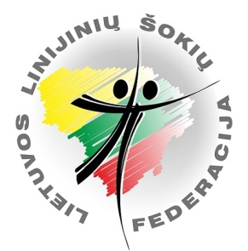
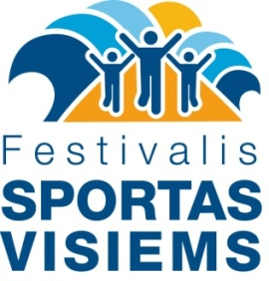
„Palanga Dance Open 2020“
INVITATION
Time: 2020 20th of September 9.00 – 15.00
9.00 – Line dance solo; 12.30 – Dance teams
Venue: Sporto g. 3, Palangos sporto arena, Palanga

Participants: children, teen , adult, adult senior, senior.
Dance divisions:
• Line dance Solo classic
• Line dance teams: ProAline, ProTeam Starter, ProTeam Newcomer
• Dance teams of different genres: Line Dance Team, Solo Latino Team, Partner Team, ShowTime (Showdance) Team, Freestyle Team (Pop dance, street dance, zumba, salsation, ballet, neoclassical dance, folk dance and etc.)
LINE DANCE SOLO CLASSIC DANCES
DANCE LEVEL | Dance style | Dance name
Starter Kids  Starter Children | 0-9 m.  10-13 m. |  | Tell me
Starter | Pulse  Cuban  Street (iki 29 m.)  Stage (nuo 30 m.) |  | Boogie Jive  Cha Cha Lolita  Tell me  Sixties Dance Medley
Newcomer | Pulse  Cuban  Street (iki 29 m.)  Stage (nuo 30 m.) |  | In Love  Live Forever  Sushi  Boogie Woogie Bugle Boy
Novice | Rise&Fall  Smooth  Cuban  Street (iki 29 m.)  Stage (nuo 30 m.) |  | Rainbow Connection  Some Kind Of Wonderfull  Katchi  Treat‘Em Right  Jailhouse Rock
Intermediate |  |  | http://solodance.lt/varzybu-sokiai
Advanced |  |  | http://solodance.lt/varzybu-sokiai
ProTeam Starter | Pulse  Cuban  Team optional dance |  | Boogie Jive  Cha Cha Lolita  Team optional dance
ProTeam Newcomer | Pulse  Cuban  Team optional dance |  | In Love  Live Forever  Team optional dance

The competition is held in accordance with the rules of the Lithuanian Linedance Federation (LLDF).
Line dance Solo classic dance videos and descriptions can be found here http://solodance.lt/varzybu-sokiai
Prices:
• Starter, Newcomer - 21 Eur.
• Starter Kids, Children - 8 Eur.
• Novice, Intermediate, Advanced - 31 Eur.
• ProTeam-10 Eur.
• ProAline -8 Eur. participant.
• Dance teams of various genres - 10 Eur. (2 dances can be performed)
ATTENTION! When dancing in line dance solo division and in dance teams, there is no separate fee for dance teams!
Free for viewers!
Registration of participants until 2020 10th of September.

Information about the event Neringa Kirklienė tel. +370 698 13428, el. Email: nksokiumokykla@gmail.com
www.solodance.lt

