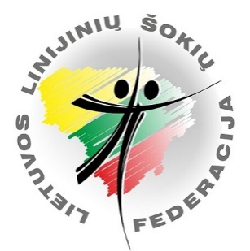
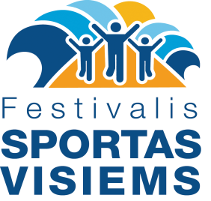
Festival "Sport for all 2020"
2020 18-20 of spetember, Palanga

International Line dance SOLO festival "PALANGA 2020"
Dance Festival-Competition
„PALANGA DANCE OPEN 2020“

Schedule of dance festival

18th of september (Friday)

19.00-19.45 Line dance flashmob and Jerusalema Ez dance rehearsal. Venue: Sporto str. 3, Palanga stadium.
20.30-21.30 International Line Dance Solo festival "PALANGA 2020" dance program rehearsal (15 dances).Venue: at the begining of Basanavičiaus strt., near Vytauto strt. to Birutės alley.

19th of september (Saturday)

9.00-10.00 Morning dancing near the sea. International Line Dance Solo festival "PALANGA 2020" dance program (15 dances) at the Palanga beach. Venue: Near Palanga bridge cafe (from left side).
10.00-11.00 March-parade of all festival participants from Jūratė & Kąstytis square to Palanga stadium.
11.00-12.00 Opening ceremony of the festival. Line dance flashmob and Jerusalema Ez dance. Venue: Sporto str. 3, Palanga stadium.
12.45-13.30 Show programs of dance teams on stage. Venue: Jūratės and Kąstyčio square, stage.
14.15-15.00 International Line Dance Solo festival "PALANGA 2020" (15 dances) lining up of all participants at Basanavičiaus strt.
15.00-16.00 International Line Dance Solo festival "PALANGA 2020" (15 dances). Basanavičiaus strt., from Jūratės and Kąstyčio square to Birutės alley.
21.00-23.00 Line dance party, workshops, show program. Party theme „Chequered“.
Venue: Sporto str. 3, Palanga stadium.

20th of september (Sunday)

9.00-15.00 Line dance solo and dance teams festival-competition.
“PALANGA DANCE OPEN 2020”
Venue: Sporto str. 3, Palanga stadium.

Closing of the festival “Sport for All 2020” Until next year!

Participant fee - 5 EUR.
For the participants of the competitions “PALANGA DANCE OPEN 2020“, 5 eur festival fee is included to competiton participant fee.

Festival website www.solodance.lt

Contact person: Neringa Kirklienė mob. +370 698 13428, e-mail: neringa.kir@gmail.com

