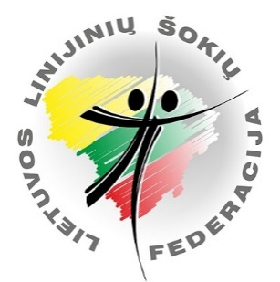
International Online Dance Festival-Competition

„New Line 2021“

INVITATION

Dates: To 2021 y. May 30 registration and payment
To 2021 y. June 05 video upload
2021 y. June 20 live festival-competition broadcast
Place: Online https://www.twitch.tv/nksokiumokykla

Participants: Children, youth, adults, seniors.
Competition divisions:
- New Line Solo.
- Linedance Teams: ProTeam Starter, ProTeam Newcomer.
- Dance teams: Solo Dance Team, Solo Latino Team, Partner Dance Team, Freestyle Team
NEW LINE SOLO DANCES
Division | Dance style/Name
Starter Kids (0-9 m.)  Starter Children (10-13 m.) | Steet | My Ritual
Starter | Latino (Salsa)( all age)  Street (to 29 age)  Stage (Charlston) (under 30+ age) | Hola  My Ritual  Rhythm
Newcomer | Latino (Bachata)( all age)  Street (to 29 m. age)  Smooth (Tango) (under 30+ age) | Bailando El Amor  Suchi  Love‘s Tango
Novice | Smooth (West Coast Swing) (all age)  Street (all age) | My Love Goes On  Swalla
Intermediate | Latino (Samba Style) (all age)  Smooth (Night Club) (all age) | I‘m over You  You‘re Hero
ProTeam Starter | Latino (Cha Cha Style) (all age)  Team Selection Dance | Love You Cha  Team Selection
ProTeam Newcomer | Rise & Fall (Waltz) (all age)  Team Selection Dance | Lay Here With Me  Team Selection

The competition is held according to the rules specifically for this online event.

The competition rules and registration form can be found here http://solodance.lt/new-line-2021
Tutorial videos, descriptions and special music for the competitions for New Line SOLO and linedance ProTeam can be downloaded here http://solodance.lt/new-line-2021

Prices:
• New Line Solo Participants - 11 Eur. (One dance program)
• New Line Solo Participants - 21 Eur. Two dance programs
• New Line Solo Starter Kids, Children- 5 Eur.
• ProTeam team participants -5 Eur.
• Dance teams - 5 Eur. One dance.
• The highest entry fee for dancing in more than two divisions is 21 Eur.
Please transfer the participation fee by 2021. May 30
Please transfer the participation fee to:
Company: Všį “LINEDANCE”
Company code: 302492489
Adress: Vytenio 55-3, LT-03209, Vilnius
IBAN LT60 7044 0600 0748 0046
SWIFT / BIC CBVI LT 2X (SEB Bank)

Information about event in Lithuanian and Russian: Neringa Kirklienė tel. +370 698 13428, In English: Gintarė Norvilė +370 648 15363
E-mail: nksokiumokykla@gmail.com www.solodance.lt

