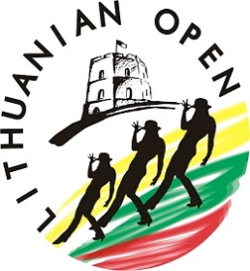
LITHUANIAN OPEN 2023&
LITHUANIAN TEAMS DANCE CUP 2023
SCHEDULE
Friday
20.00-23.00 Welcome Party (we also will repeat all competition dances)

Saturday
8.15 REGISTRATION
9.00 -10.25 Warm up & competition
Novice Teen prelims
Newcomer Primary
Newcomer Youth
Newcomer Teen Crystal
Newcomer Diamond
Newcomer Silver Gold
10.30-10.35 Novice awards for prelims
10.35-12.30 Warm up & competition
Advanced Open Diamond Silver
Advanced Crystal
Intermediate Open
Intermediate Diamond Silver Teen
Novice Youth Open
Novice Diamond
Novice Silver Gold Platinum
UCWDC SOCIAL
12.30-13.45 Warm up & competition
Novice Teen finals
Starter Primary Teen
Starter Youth 10-11
Starter Youth 12-13
Starter Silver Gold
Starter Kids
13.45-14.15 Lunch
14.15-16.00 Warm up & competition
ProAm NON UCWDC Starter Open, Newcomer Teen,
ProAm UCWDC Novice Platinum
Superstars A+B
Showcase Open Crystal Diamond
Choreography
16.00-17.00 Pro Team Competition
Proteam Starter Adult Senior, Open, Senior, Junior
Proteam Newcomer Adult Senior
17.00-18.45 TEAMS

19.00 Show Time
19.15-20.00 Awards
20.00-24.00 Party Time

NO COMPETITION ON SUNDAY

